|  |
| --- |
| EPAM Systems, RD Dep., RD Dep. |
| MTN.NIX.05.Zabbix.Basics |

|  |  |  |  |  |  |
| --- | --- | --- | --- | --- | --- |
| REVISION HISTORY | | | | | |
| Ver. | Description of Change | Author | Date | Approved | |
| Name | Effective Date |
| 1.0 | Initial Version | Siarhei Beliakou | 23/May/2017 |  |  |

**Task. Zabbix. Basics**

**Testing Infrastructure:**

Vagrantfile to spin up 2 VMs (virtualbox):

* zabbix server, provisioned by Vagrant provisioner
* Zabbix agents on both VMs, provisioned by Vagrant provisioner

Configure zabbix to work on the server directly without /zabbix

<http://zabbix-server/zabbix> -> [http://zabbix-server](http://zabbix-server/)

**Task:**

You should install and configure Zabbix server and agents.

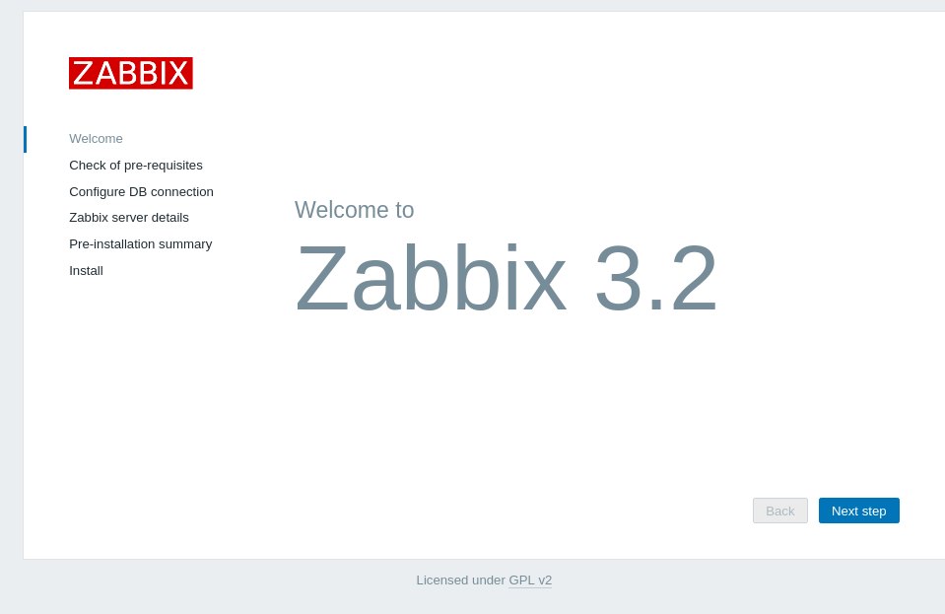

1. **Using Zabbix UI:**
   * Create User group “Project Owners”

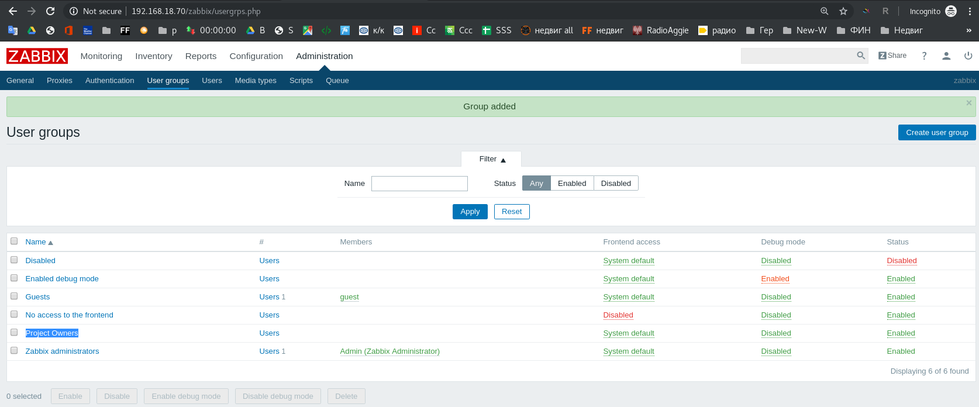

* + Create User (example “Siarhei Beliakou”), assign user to “Project Owners”, set email

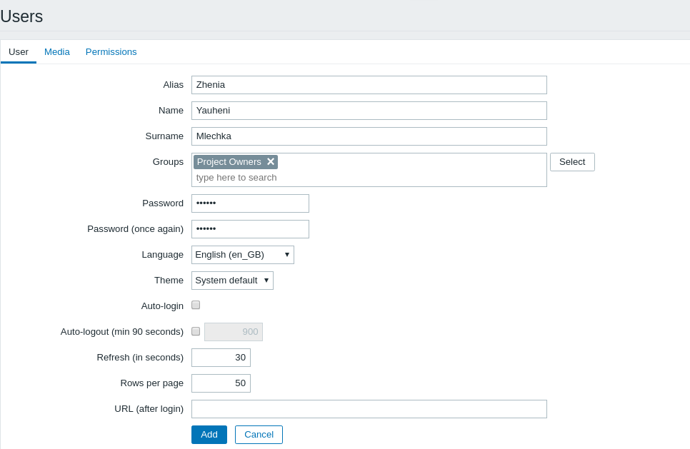

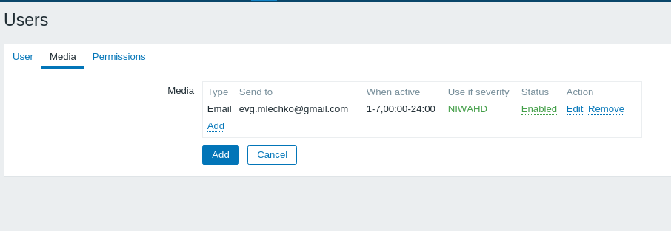

* + Add 2nd VM to zabbix: create Host group (“Project Hosts”), create Host in this group, enable ZABBIX Agent monitoring

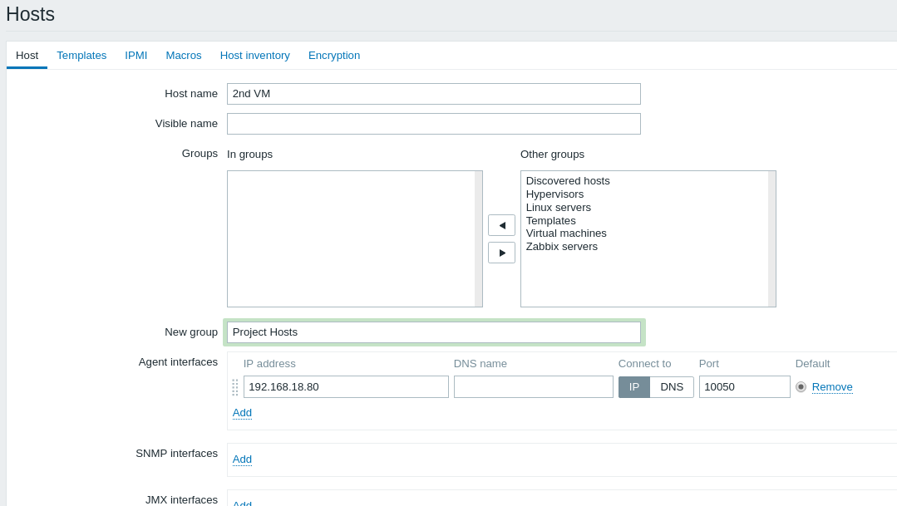

* + Assign to this host template of Linux

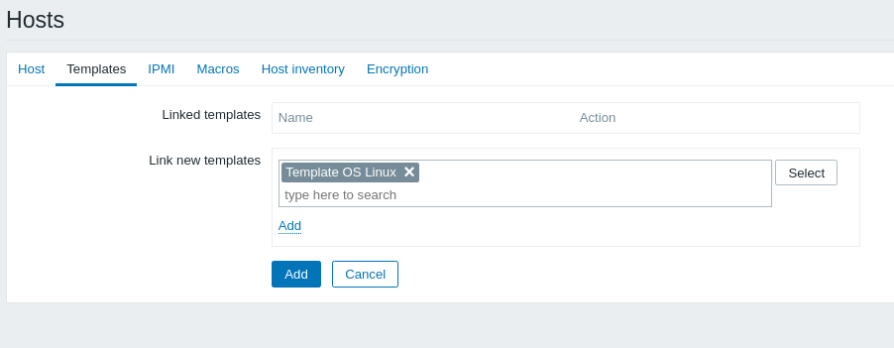

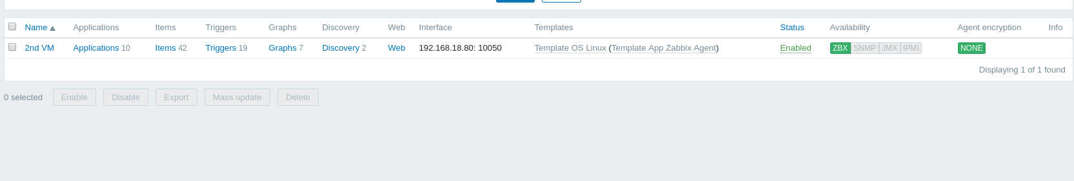

* + Create custom checks (CPU Load, Memory load, Free space on file systems, Network load)

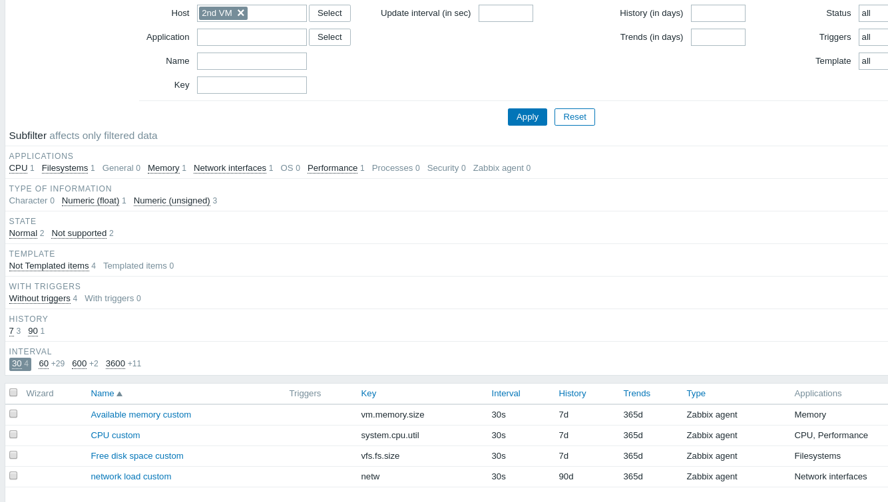

* + Create trigger with Severity HIGH, check if it works (Problem/Recovery)

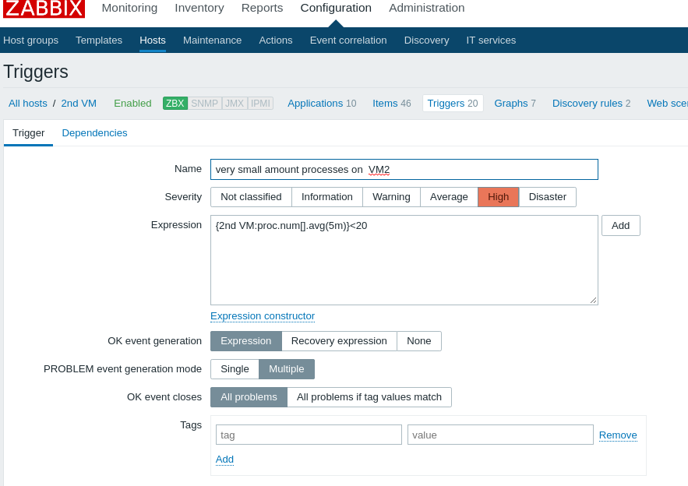

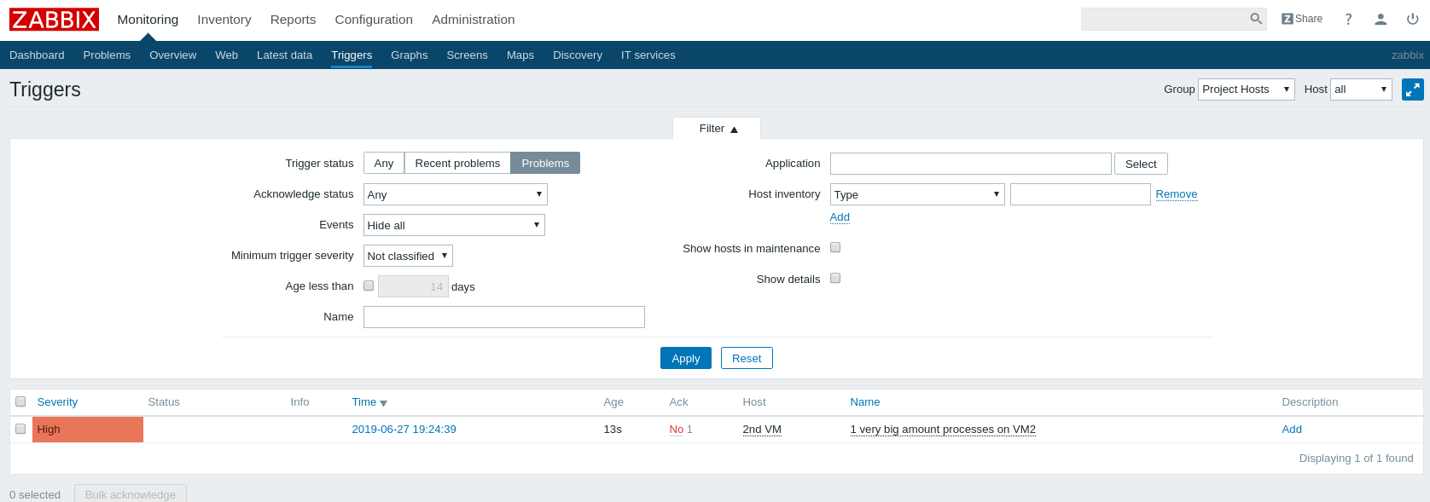

* + Create Action to inform “Project Owners” if HIGH triggers happen

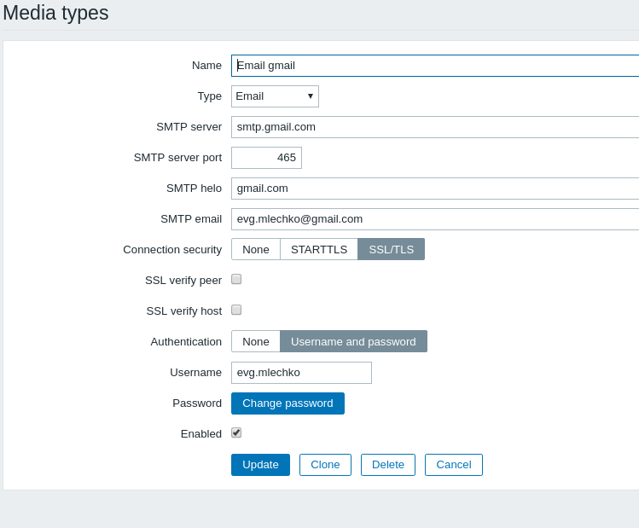

For both VMs use vagrant box “sbeliakou/centos-7.3-x86_64-minimal”

1. **Using Zabbix UI:**
   * Configure “Network discovery” so that, 2nd VM will be joined to Zabbix (group “Project Hosts”, Template “Template OS Linux”)

For both VMs use vagrant box “sbeliakou/centos-7.3-x86_64-minimal”